Company Business Model

In 2009, Mr. Harry Peter, founded a Baby Toy Company LLP, in United States, its headquarters in Los Angeles, CA. The company was selling premium toys but the business had been stagnant over the years. Harry Peter was looking at bringing in new offerings to increase revenue. A survey was conducted on kids and their preference for toys and it was found that attention span/engagement with a new toy lasts only few days for kids and they start demanding a new one within a week. However, the survey also brought out that parents found affording premium toys difficult. Like any businessman, Harry Peter saw an opportunity here and decided to launch a new offering of premium toys being available on rent. He directed his IT team to make rental option for customers available on their online portal <http://baby-toy-company.xyz>

You are expected to deliver the application in phases getting regular feedback from all stakeholders. The application development has to be done in sprints and should follow Agile methodology.

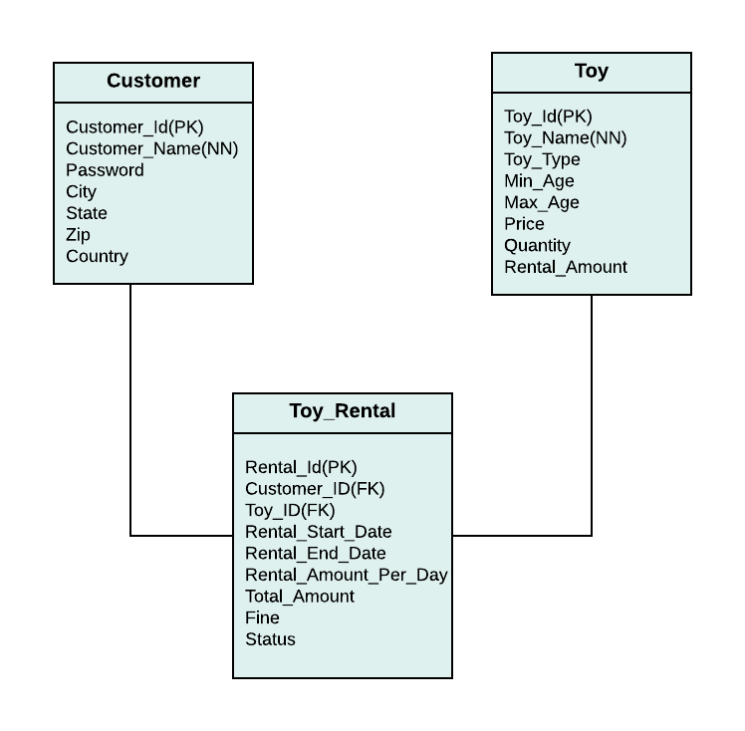

|  |
| --- |
| Java |
| OOPS and Exception Handling |
| JDBC |

Sprint Outcome

|  |  |  |  |
| --- | --- | --- | --- |
| **Topic Name** | **Sprint** | **Learning Outcome** | **Business Outcome** |
| OOPS | 4 | 1. Understanding the object, constructor and OOP principles 2. Understanding the POJO class 3. Instance variables , static variable and its need. 4. Handling Runtime errors / Exception with the help of try/catch and throw 5. Creating user defined exceptions 6. Understanding the object class toString method and overriding 7. Understanding overloading by creating a search method with different parameter like id and name | * Records the data about the customer and toy which are valid * Provides meaning full information to the user when the unexpected event occurred . * Generating customized information for the invalid data * Provides the information about the availability of toys and customer information |
| JDBC | 6 | 1. Records the data into a data base using JDBC 2. Understanding the connection and DAO class 3. Understanding the singleton class 4. Performing transaction between the objects 5. Statement and PreparedStatment difference 6. ResultSet Object | * Records the customer , toy and the rental details * Reports about the rental details of customer * Report on Rental details of a specific toy * Booking the toy for a customer * Report on available toys |

Below are the list of requirements captured by a Business Analyst. Requirements are in terms of business outcome and use cases. Learning outcomes will be the takeaway for you (developer) as you implement these requirements. You will be graded on the learning outcomes that you will achieve.

**Object Oriented Programming and Exceptions**

1. Create Customer and Toy class as per the table structure with setter and getter methods.
2. Create the parameterised constructor to pass the values to the instance variables for both Customer and Toy object .
3. Override the toString method of the object class to display the respective details of customer and toy class.
4. Setter method and the constructor of the Customer class must throw an InvalidNameException if the length of is less than six and has numbers/ special characters
5. Setter method and the constructor of the min age and max age should throw an InvalidAgeException if the age is not between 0 and 12
6. Create an interface as CustomerService and ToyService and add methods such as insert,search and display.
7. Create CustomerServiceImpl and ToyServiceImpl class with the stataic array CustomerArray and ToyArray respectively and override methods insert and display the objects
8. Search method should be overloaded with different parameters id and name for both CustomerService and ToyService
9. Create classes like ElectronicToy , MuscialToy as a subclass of toy and add attributes such as numberofbatteries , operatingmode (remote/manual) for ElectornicToy and noOfSpeakers for Musical toy
10. Create TestApp class to test the program

**JDBC**

1. Create a singleton DAO class for database connection object.
2. Modify/create the CustomerServiceImpl and ToyServiceImpl class and store the information on a table
3. Perform CRUD operation on all the object.
4. Create a bookToy method on ToyRentalService to book the toys.
5. Create a returnToy method to return the toys.
6. Create a getRentalDetails(int customerId) method to fetch the rental details of the customer.
7. Create a toyRentDetails(int toyId) method to get the toy information.
8. Create a getTotalRentAmount() method to display the total rental amount for the month.
9. Create a TestApp class which will get the input from the user and perform the appropriate action.